APPENDIX A
PHOTOGRAPHS TAKEN DURING JIV AT 16” TUNU-BRASS CREEK DELIVERY LINE AT AGBIDIAMA COMMUNITY, EKEREMOR L.G.A, BAYELSA STATE ON 29TH FEBRUARY, 2024.
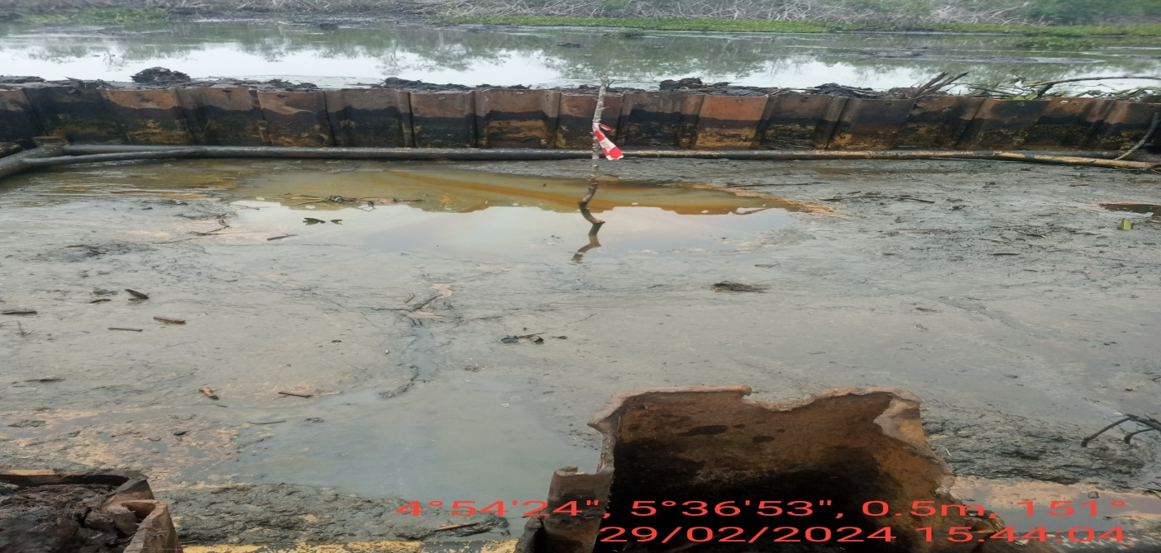
Fig.1: The incident area at the time of arrival
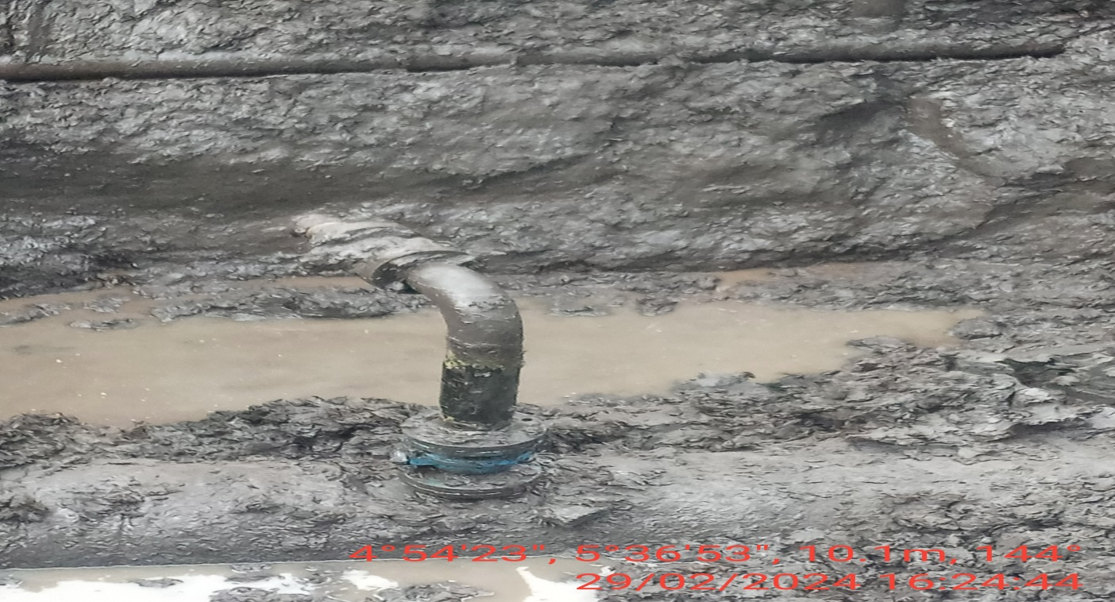
Fig. 2: 4” valve with line installed at 12 O’ clock position of the pipeline

